Tutorial 8

Module Name: Bugzilla and testlink
Test Case ID: TC08
Tester Name: Vora Riya

- I could not access TestLink hence used GoogleSheet

Scenarios:
- Scenario ID: T01
Scenario
Create test case sheet (test management)
Test Steps
1. Open Google Sheets & Create a Blank spreadsheet
2. Name it 'Tutorial 8 Sheet'
3. Add the header block and the scenario table
4. Save
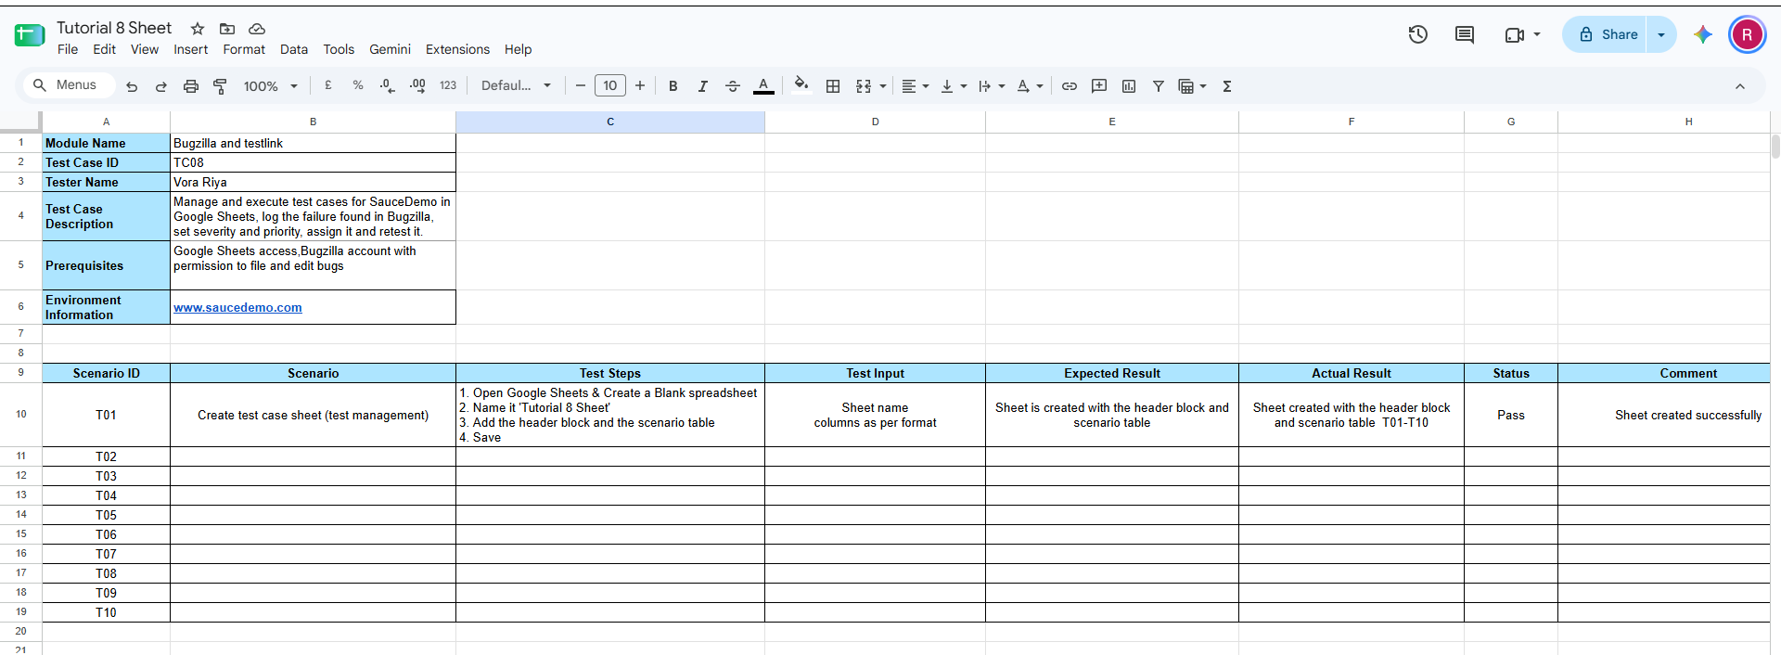

- Scenario ID: T02
Scenario
Valid login
Test Steps
1. Open https://www.saucedemo.com
2. Enter username
3. Enter password
4. Click Login
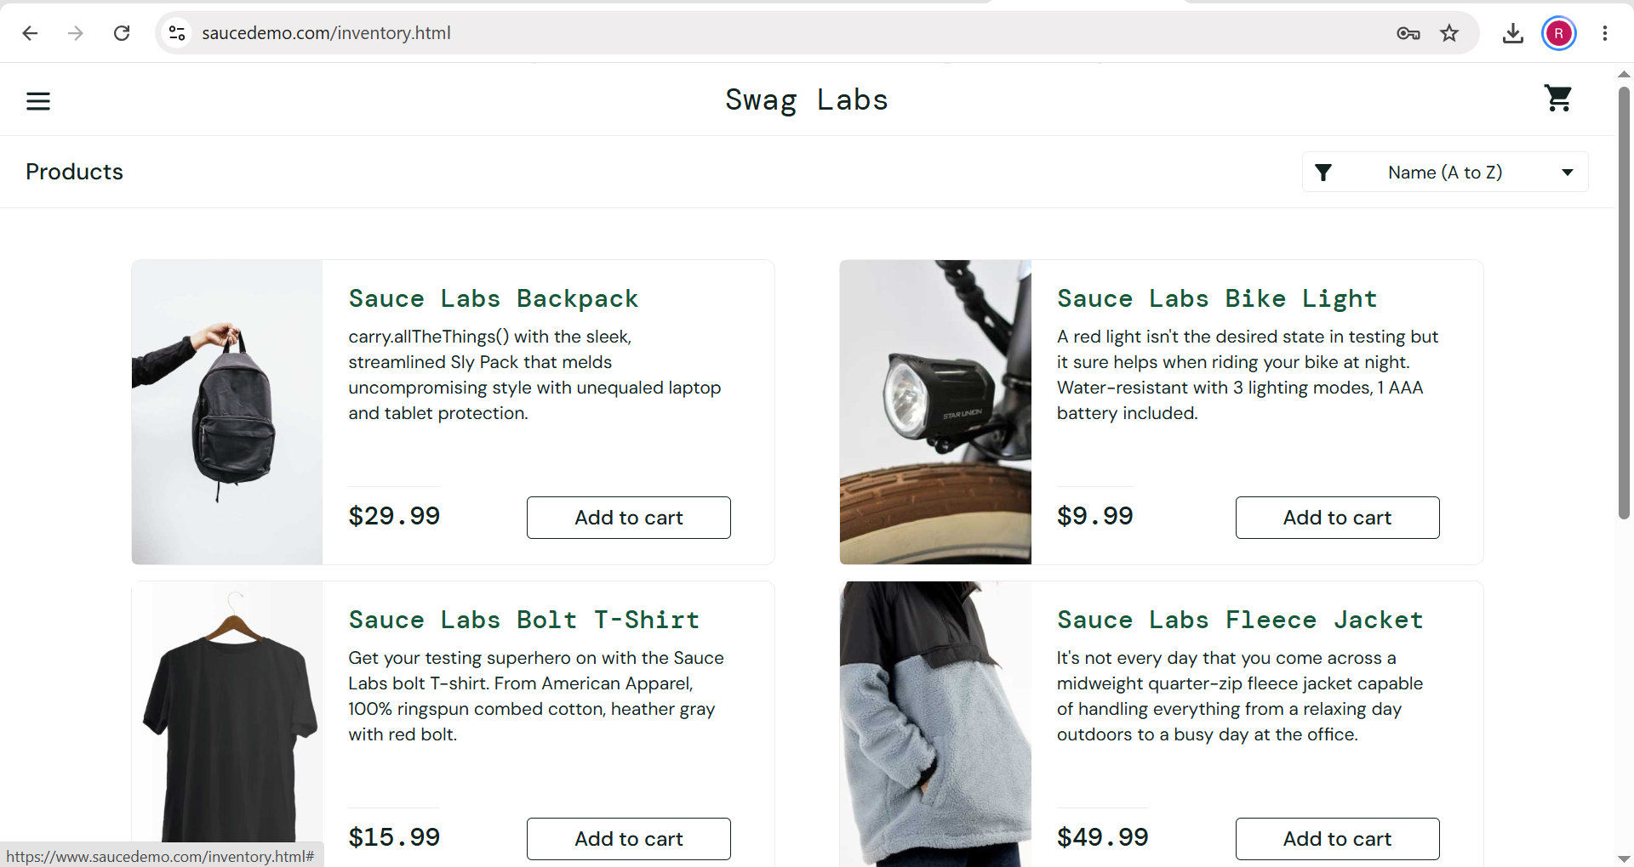

- Scenario ID: T03
Scenario
Add item to cart
Test Steps
1. Log in
2. Click 'Add to cart'
3. Check the cart badge
4. Click the cart icon
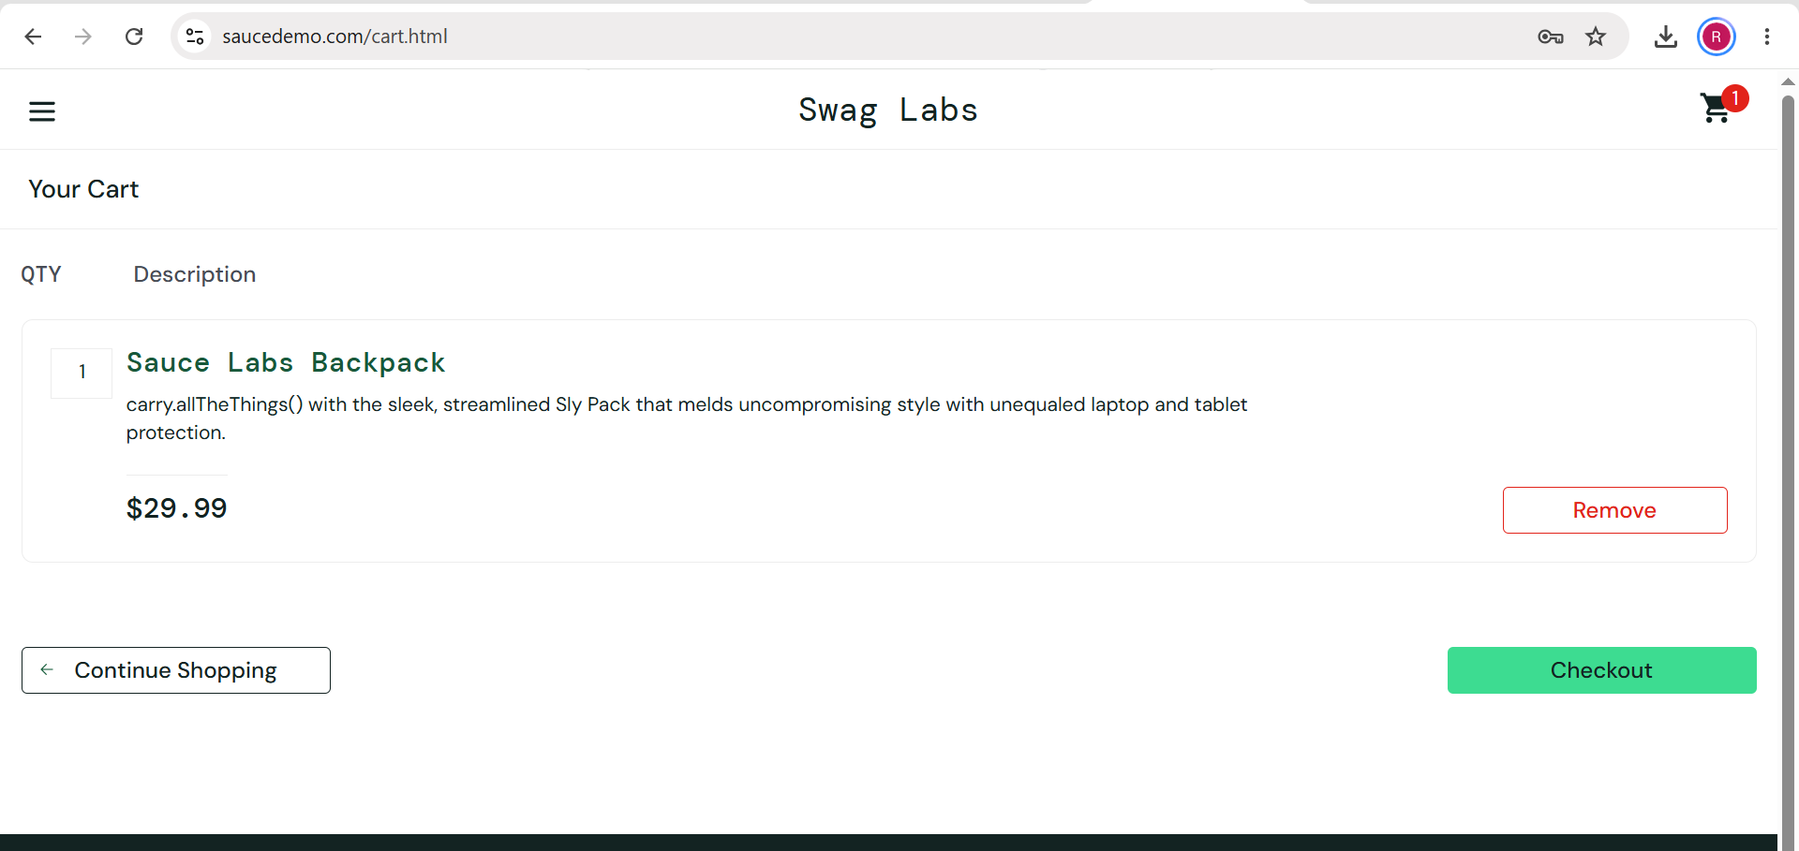

- Scenario ID: T04
Scenario
Product images
Test Steps
1. Log out and log in as problem_user
2. Compare the images of the products on the Products page
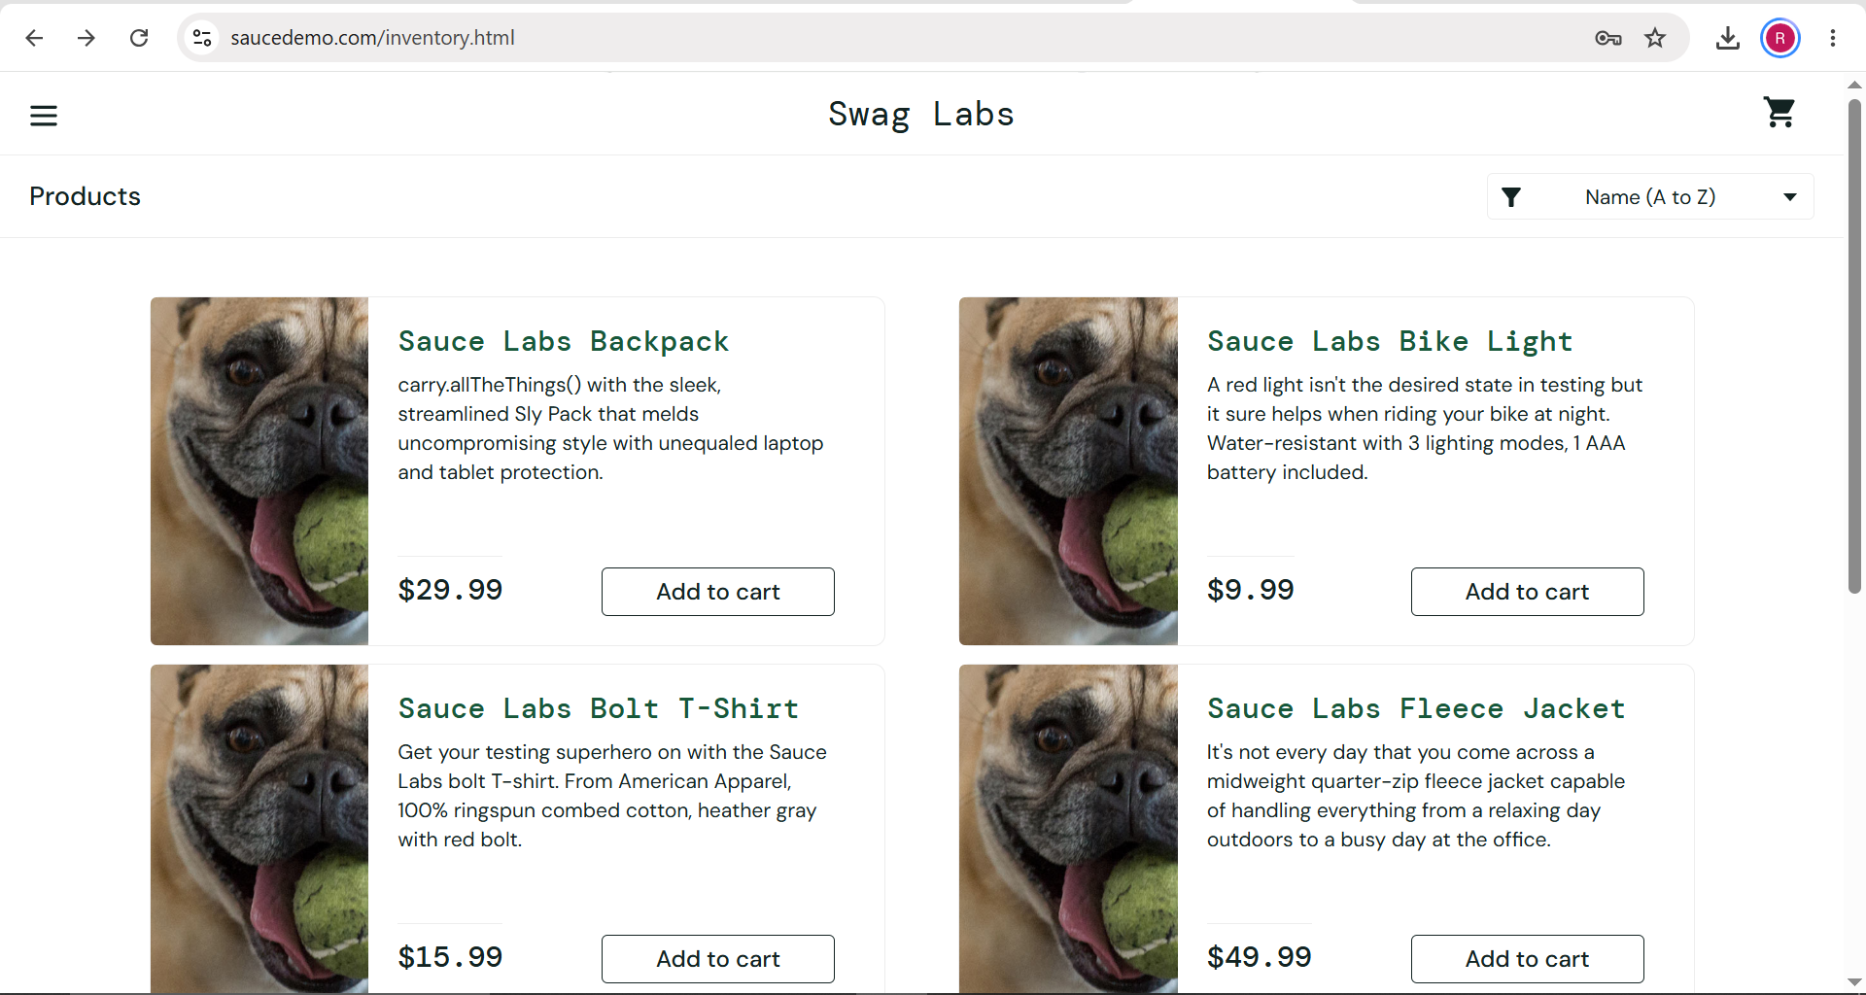

- Scenario ID: T05
Scenario
Create defect in Bugzilla
Test Steps
1. Log in to Bugzilla
2. Select product, component, version
3. Enter summary and description
4. Attach the screenshot
5. Click Submit Bug
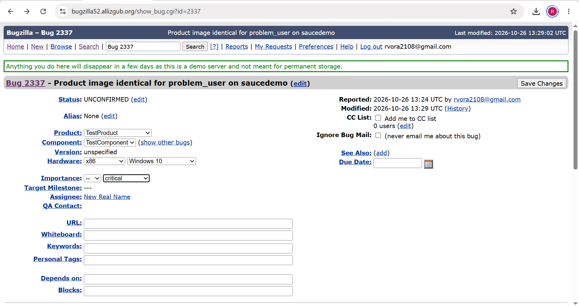

- Scenario ID: T06
Scenario
Assign severity to the defect
Test Steps
1. Open the bug
2. Set Severity field
3. Click Save Changes
4. Check the History
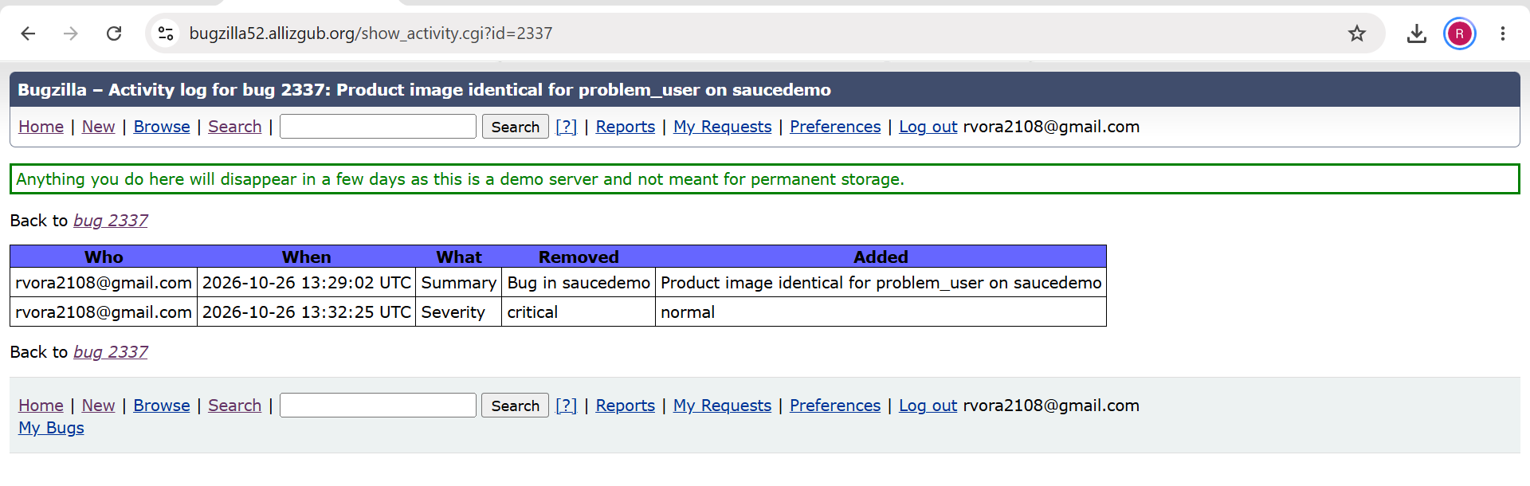

- Scenario ID: T07
Scenario
Assign priority and developer
Test Steps
1. Open the bug
2. Set Priority
3. Change 'Assignee' to the developer account
4. Set Status to IN_PROGRESS
5. Click Save Changes

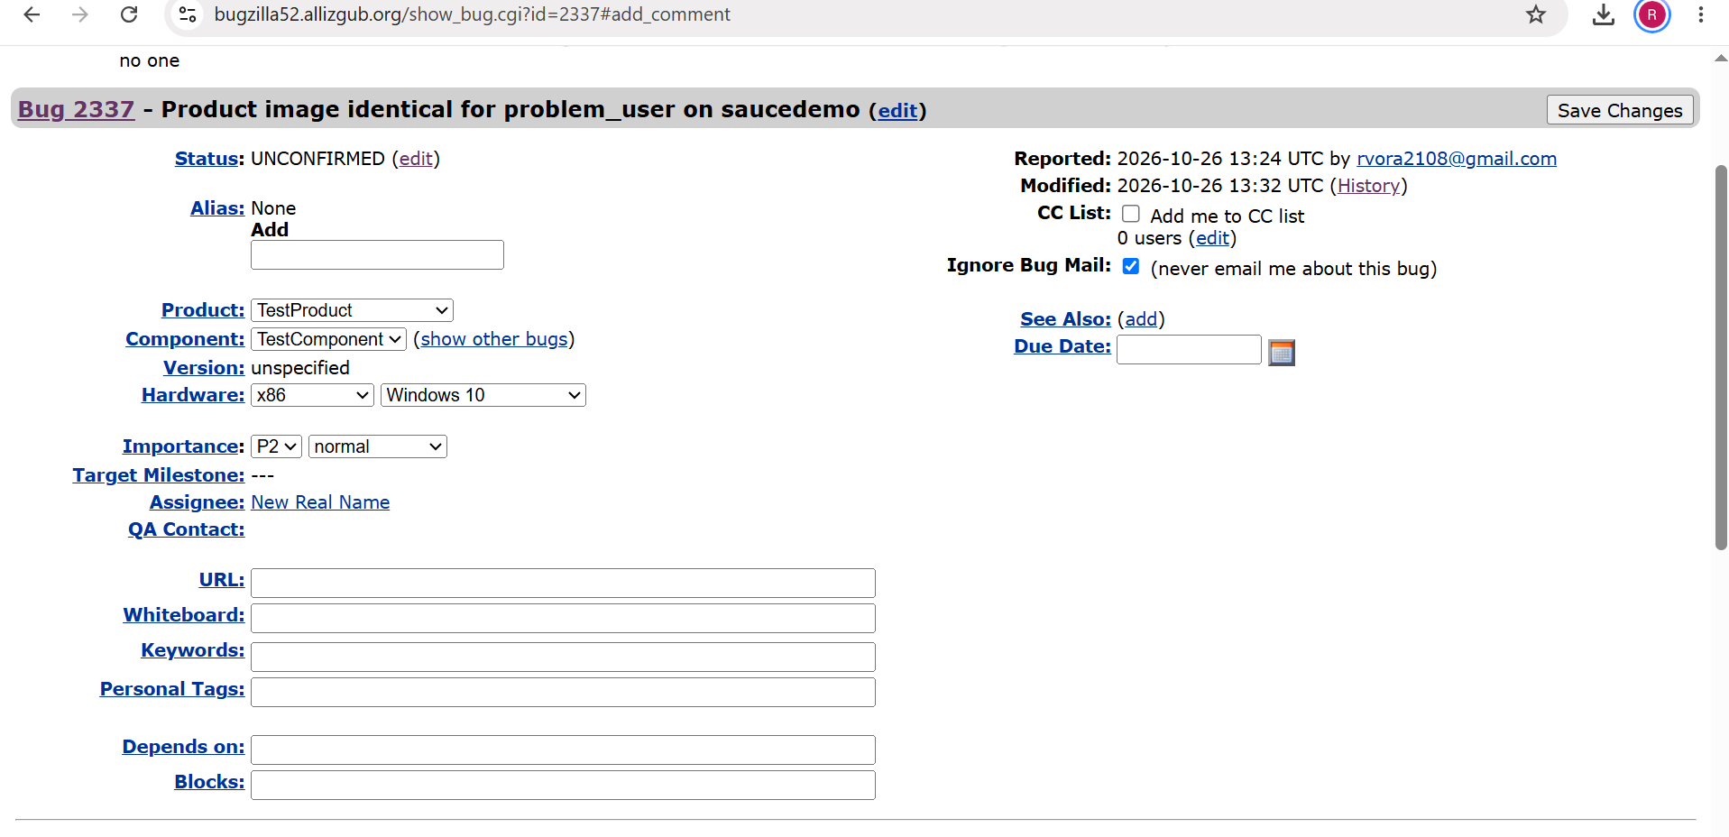

- Scenario ID: T08
Scenario
Mark defect as fixed
Test Steps
1. Open the bug
2. Set Status to RESOLVED and Resolution to FIXED
3. Add comment 'Fix ready for retest'
4. Save Changes
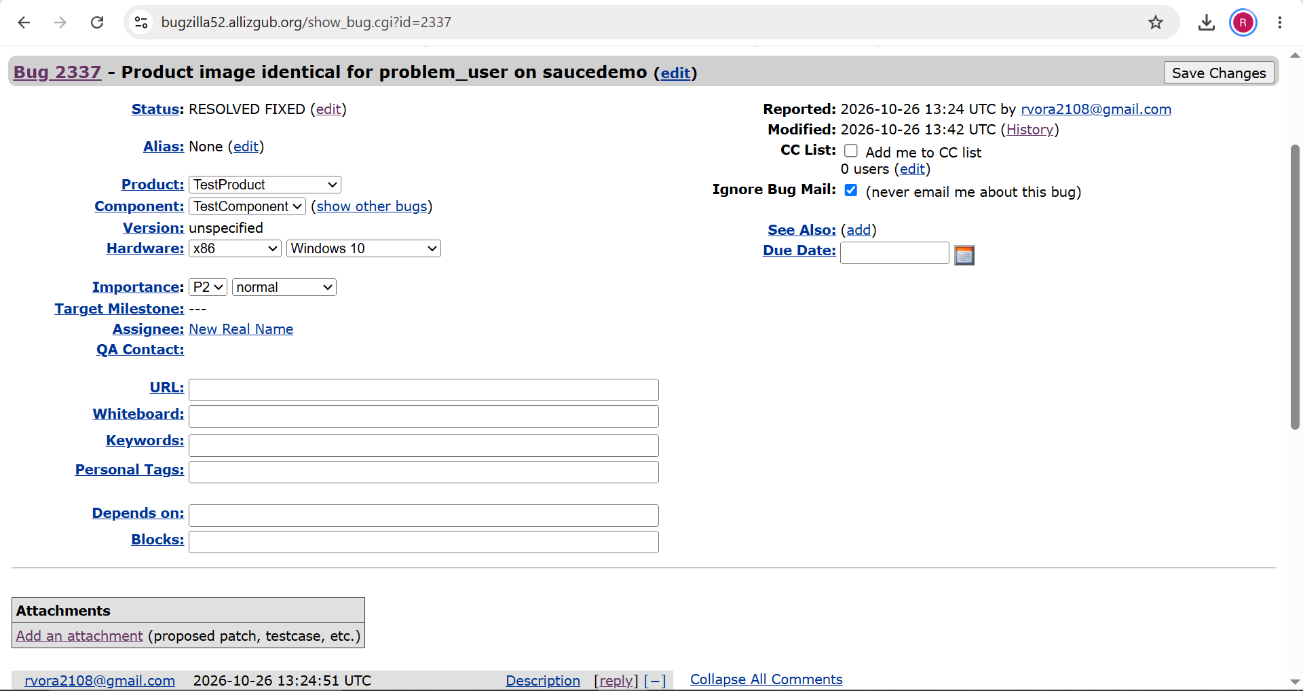

- Scenario ID: T09
Scenario
Retest defect
Test Steps
1. Open SauceDemo
2. If images are correct set bug to VERIFIED
3. If not, set status to REOPENED
4. Add a retest comment and Save

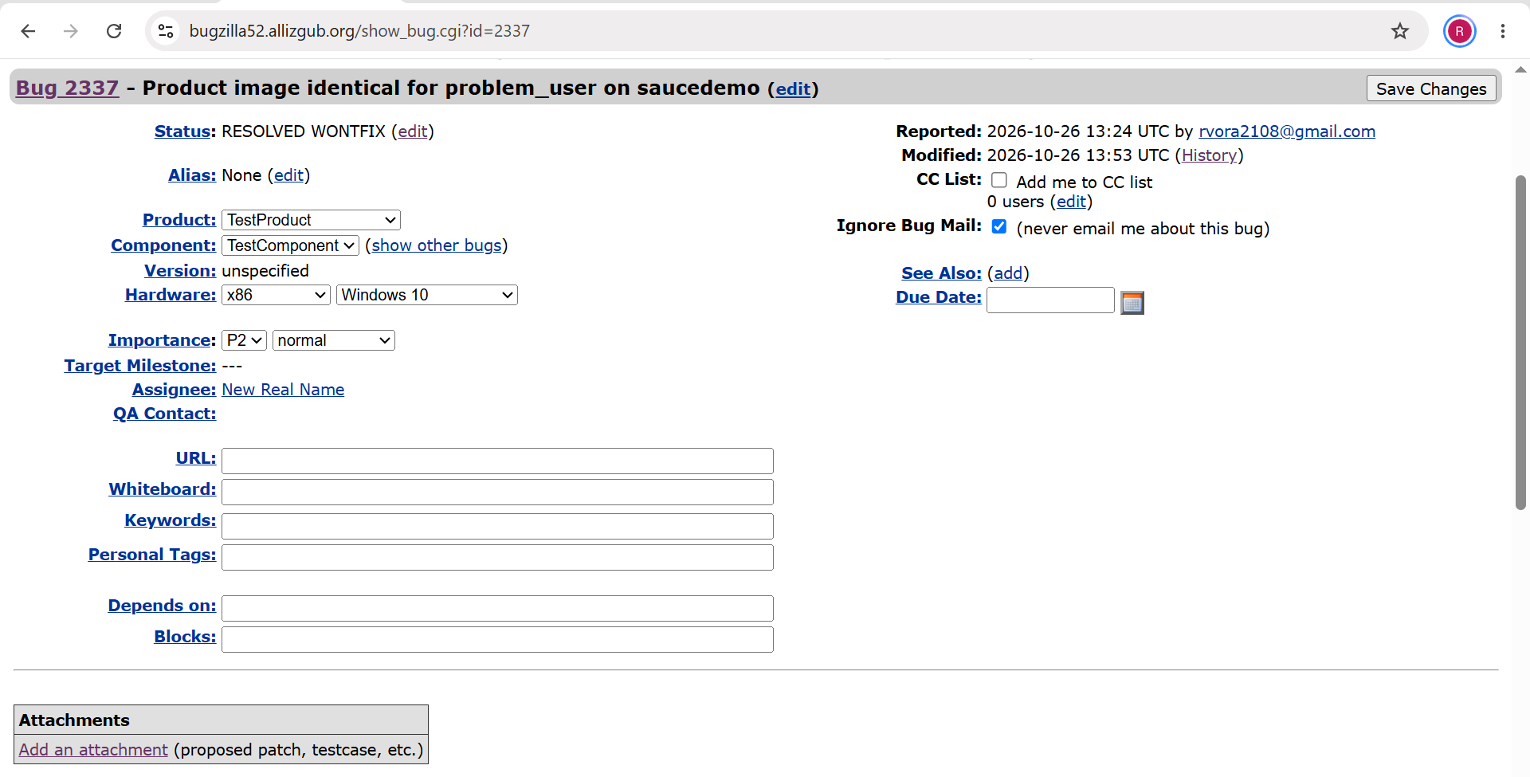

Test Result Summary

Executed (T02–T04) | 3
Passed | 2
Failed | 1
Pass % | 66.67%

